

Prepared by:

**Gerber Technology**

**YuniquePLM**

**Line List Folder**

A line list is a quick and easy way to group together multiple style folders so that they can be viewed and edited in one location. To access or create a line list, click on the Line List header from the YuniquePLM desktop screen.

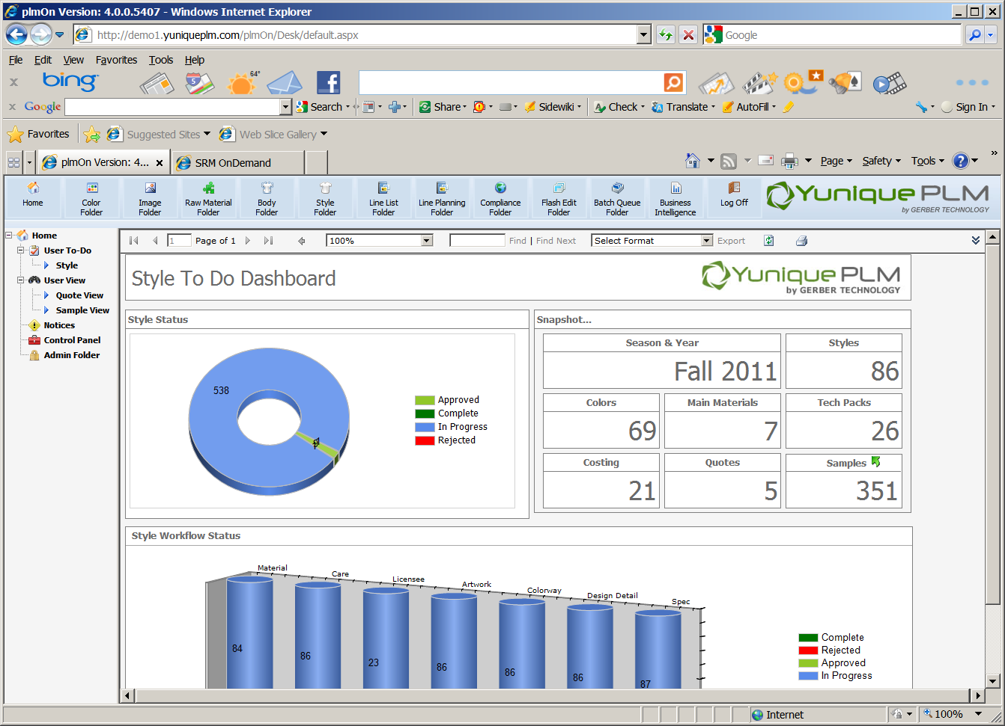

When the Line List folder opens, any existing line lists will be presented on the right hand side of the explorer window. Search filters are listed across the top to help in accessing specific line lists. Enter data or select from the drop down list provided and then click the Search button on the far right to filter.

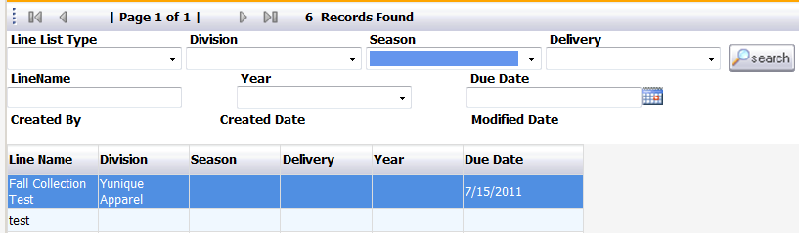

To create a new line list, select the New Line List node on the left navigation or click the New button across the top of the screen.

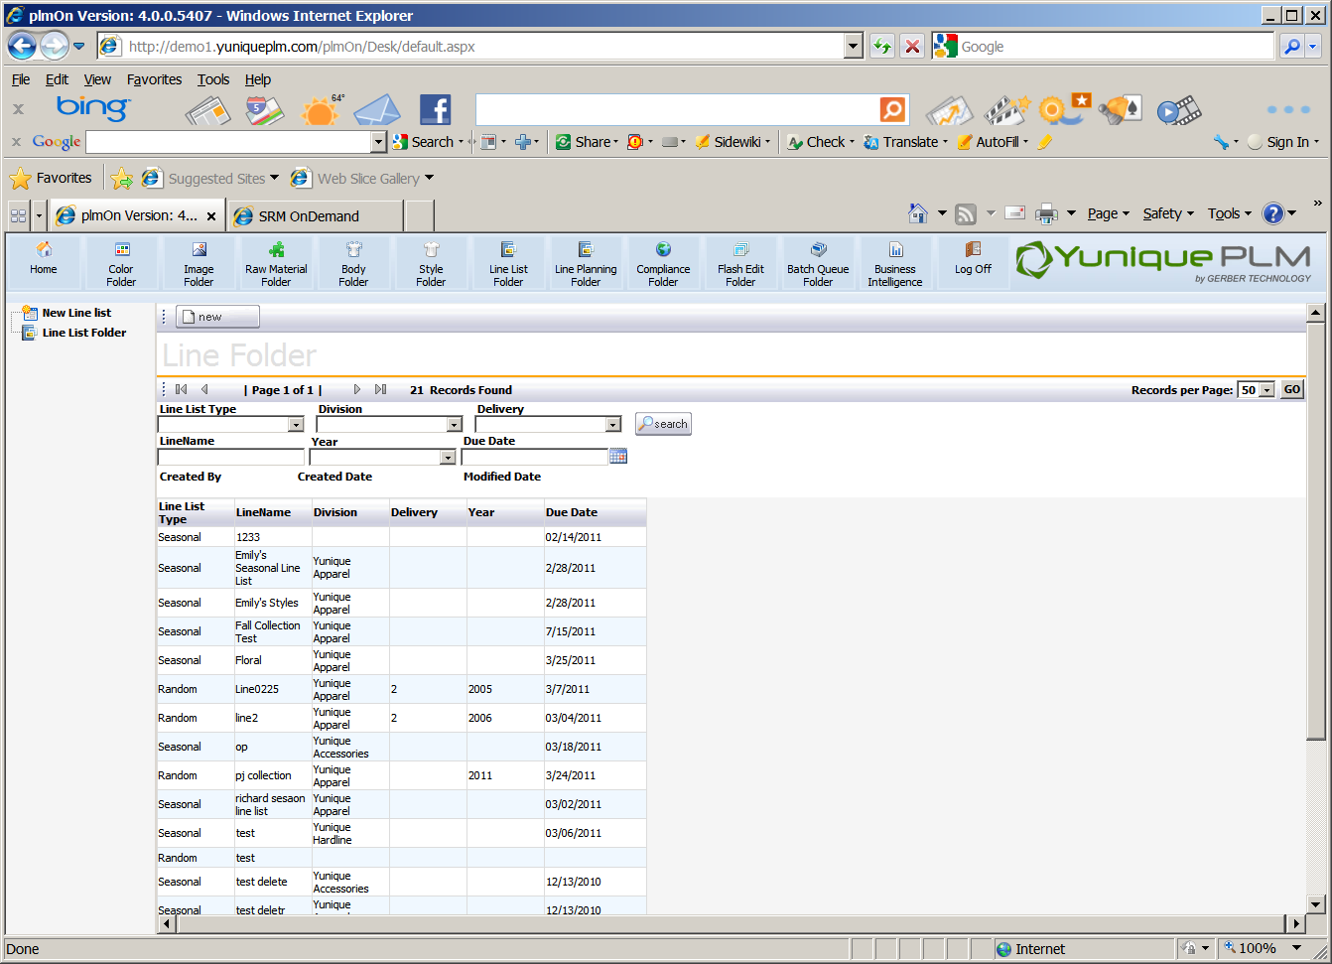

Enter the appropriate data in each of the available fields and then click the save button across the top of the screen.

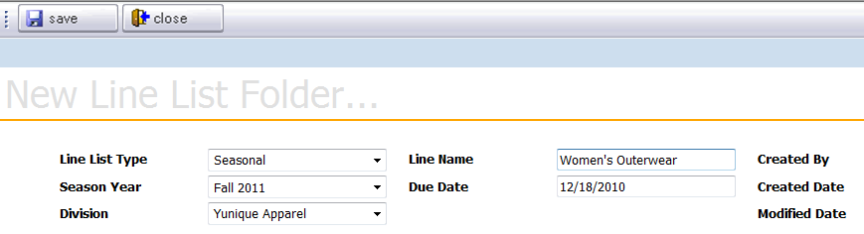

Once the new line list record has been saved style folders can be added by clicking the Add button across the top of the screen.



All available styles will be presented. The styles can be automatically filtered using the fields across the top of the screen. Place a check mark in the upper left corner of the style thumbnail images to be included on the new line list and then click the Add button in the upper right. Once all styles have been selected, click the Close button to return to the Line List.

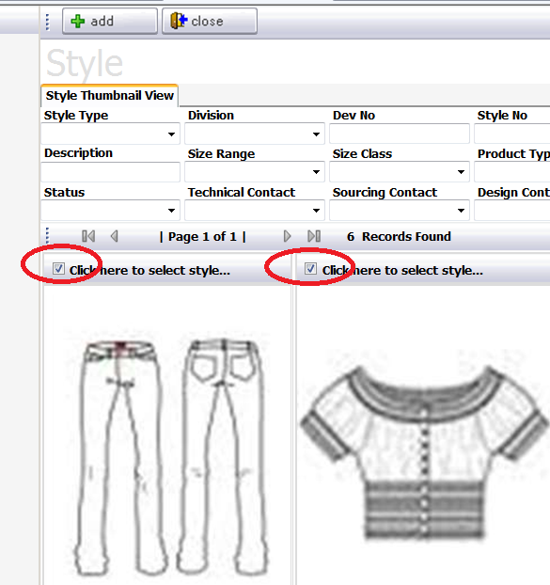

They selected styles will be presented on the line list with color information and style header data beneath the thumbnail image. The number of styles on the line list will be displayed in the center of the screen directly above the images. If there are more styles on the line list than will fit on the screen at one time, the pages will be listed as 1 of XX. The arrow controls can be used to access the next page grouping of styles.

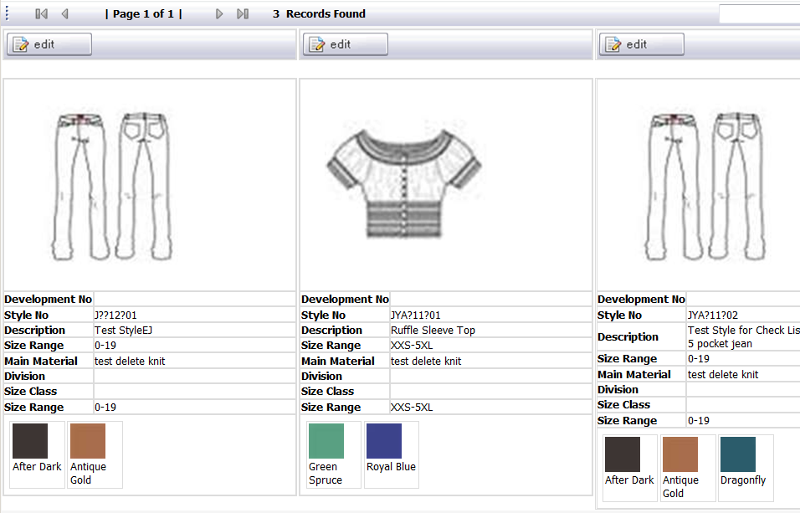

Clicking the Edit button in the upper left corner of each style thumbnail will allow changes to be made to each individual style on the line list.



Once the individual style record is opened, changes can be made to the color combinations of that style, by clicking on the Add, Drop or Remove buttons directly below the image. Place a check mark to the left of the color combinations to be affected and then click the Save.

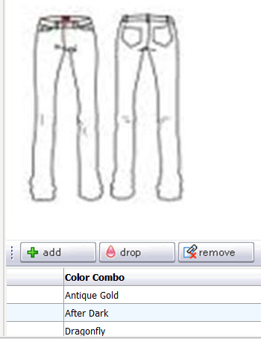

Dropping colors leaves the color combinations on the list and places a pink droplet icon to the left of the combination. Removing a color will cause the color name to be deleted from the color combination list completely.

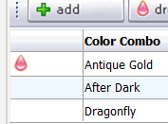

To change information within a style folder that is not displayed on the line list, click on the Go To button across the top of the screen.



The full style folder will be open for any edits that are needed.

If the style is to be dropped from the line, click on the Drop Item button across the top of the screen.



A dialog will be presented to confirm that the item should be dropped. Click OK or Cancel to complete the process.

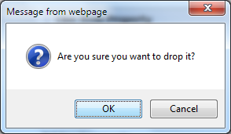

The style will remain on the line list and can be restored to an Active status if needed. A message bar will be listed above dropped styles indicated when they were dropped and by whom.

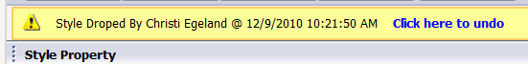

To delete and icon from the line list, click on the Remove button across the top of the screen. The item will no longer be visible on the line list at all.



A dialog will be presented to confirm that the item should be deleted. Click OK or Cancel to complete the removing process.

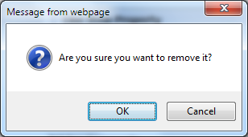

Click the Close button across the top of the screen to return to the main line list view.



From the main line list screen, items can be sorted based on the status of Active or Dropped by highlighting the specific node on the left side of the explorer window.

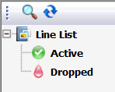

The entire line list can be printed by selecting the Print icon across the top of the screen.



Place the selection marker to the left of the desired print layout and click the Preview button to generate a PDF file. The file can then be stored on the network, emailed or sent to a physical printer.

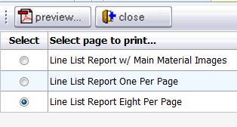

Line lists can also be burned to a CD or DVD device as another way of viewing and sharing the information. Click on the Burn Files icon across the top of the screen.



A dialog will be presented to verify that the line list should be burned to a digital media file. Click OK or Cancel to complete the process.

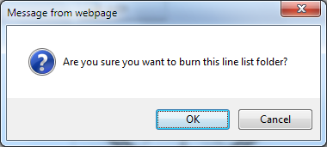

The Delete icon across the top of the screen can be used to remove several items from a line list at once or to delete the entire line list.



The line list will be presented with an available square for each style on the far left. Place a check mark next to each style item to be removed from the line list, or place a check in the square in the upper left corner labeled “Click here to delete entire folder”, then click on the Delete button in the upper left corner.

